MID TERM REPORT OF
ETL Pipeline Design for Call Centre Customer Service

A Graduate Project Report submitted to Manipal Academy of Higher Education in partial fulfilment of the requirement for the award of the degree of

BACHELOR OF TECHNOLOGY
In

Electronics and Communication Engineering

Submitted by
Shivam Pathak
Reg. No.: 160907344

Under the guidance of

Joseph Vinod Miranda |  | Dr. Somashekara Bhat
Senior Director, | & | Department of Electronic
Data Management, |  | & Communication
JLL Technologies |  | Engineering


DEPARTMENT OF ELECTRONICS AND COMMUNICATION ENGINEERING
MANIPAL-56104, KARNATAKA, INDIA

APRIL/MAY 2020

ABSTRACT

JLL is a Real Estate and Asset Management Company with offices in more than 32 countries present across 5 continents on the globe. It has business in multiple ventures, including property management for various companies. If any complaints arise within these properties, an issue is raised to the JLL Call Centers by the property manager, and the issue is handled accordingly. Data is saved at each stage of the process from the beginning until the issue is resolved completely. Data also includes information like total cost involved in each issue, time taken to resolve, net loss/profit.

This data is saved in different formats across the call centers, based on economic, accessibility and IT needs of that country. Furthermore, the raw data of each country is not generally of any use to the Business side of JLL. So, we need to pull data from sources across various call centers and perform ETL (Extract, Transform, Load) operations so that the data can be loaded to any of the data visualization tools and gain insights.

Since the data is in different format in different countries, the objective is to design an ETL pipeline to streamline the data accessibility by the business side of JLL.

The project is carried out in into following parts:
- The idea is to build an ETL pipeline using Databricks.
- It pulls the data from various sources such as MYSQL, Azure - SQL, excel sheets and lands into data Azure Blob Storage.
- Each type of service is categorized under a domain, the few domains which are widely used are: Compute, Storage, Database, Migration, Network and Content Delivery, Management tools, Security and Identity Compliance, Messaging.
- This intermediate data is read from the Azure Blob Storage through DataBricks.
- Furthermore, DataBricks Spark Architecture is used to create an ETL pipeline to refine the data for Business use out of the customer data created by various call centers throughout the globe.
The second part of the project is to make a streamline data flow between 2 completely different platforms, namely, Altryx and Leverton. Altryx platform is used by US JLL Business team, while the Leverton platform is used by Polland JLL Business team. In this part, the data is first taken from Altryx Platform and then exported into Python to streamline it and filter out datsets which are required, on the Leverton Platform. Our job is to automate this conversion process so that data transmission can take place fluently. If not, this causes a lot of human error and in turn makes the error unreliable. Automating the process of getting the data from different platforms onto one individual dashboard and furthermore making that dashboard easily accessible to the employees, is the methodology that has been adopted in this project.

With all the background information provided by ETL tools and other platforms, designing a working and deployable dashboard is one of the results that this project aims to achieve. Furthermore, this dashboard also needs to be equipped with the required authorizations to meet the security requirements stated by the organization.

The software used for this project are: Anaconda Navigator, Jupyter Notebooks, Notebook++ to read json files, along with various AWS services such as CloudWatch, cost estimators etc. The coding for this project was done in Python, the Anaconda Navigator and Jupyter Notebooks help in executing the Python script.

List of Figures

Figure No | Figure Name | Page No
2.1 | How the Altryx Platform Works | 3
2.2 | Screenshot of Altryx Platform | 7
2.3 | Screenshot of Leverton Platform | 7
2.4 | Tags in Tag Editor | 8
3.1 | Screenshot of importing Python libraries | 8
3.2 | Overall structure of the journey | 9
3.3 | Extracting, transforming and loading the datasets into the data warehouse | 10
3.4 | From final table to ready feed table | 11
3.5 | Example of JSON Scripts | 15
4.1 | Examples of JMESPath.search() execution | 15
4.2 | Snippet of JSON Format | 20
4.3 | importing datasets from Altryx Platform into Python environment | 20
4.4 | Importing datasets from Altryx Platform into Python environment | 21

Contents
 |  |  |  |  | Page No
Abstract |  |  |  |  | I
List of Figures |  |  |  |  | II
List of Tables |  |  |  |  | III
Chapter 1 |  |  | INTRODUCTION
 | 1.1 | Introduction |  |  | 1
 | 1.2 | Cloud Basics |  |  | 1
 | 1.3 | AWS Cost Management |  |  | 2
 | 1.4 | Motivation |  |  | 3
 | 1.5 | Objective |  |  | 4
 | 1.6 | Project Schedule |  |  | 4
 | 1.7 | Organisation of Report |  |  | 5
Chapter 2 |  |  | BACKGROUND THEORY
 | 2.1 | Introduction |  |  | 6
 | 2.2 | Cost Allocation Tags |  |  | 6
 | 2.3 | Strategy Used for Tagging |  |  | 7
 | 2.4 | Tag Editor and Resource Groups |  |  | 7
 | 2.5 | AWS Price Calculator |  |  | 9
 | 2.6 | CloudWatch Metrics |  |  | 9
 | 2.7 | Plotly and Dash |  |  | 10
Chapter 3 |  |  | METHODOLOGY
 | 3.1 | Introduction |  |  | 12
 | 3.2 | Problem Statement |  |  | 12
 | 3.3 | Tools/Packages Used |  |  | 12
 | 3.4 | Methodology |  |  | 13
Chapter 4 |  |  | RESULT ANALYSIS
 | 4.1 | Introduction |  |  | 17
 | 4.2 | Service Parameters Affecting Cost |  |  | 17
 | 4.3 | Data from EC2 Service |  |  | 19
 | 4.4 | Dashboard Designed |  |  | 20
 | 4.5 | Conclusion |  |  | 21
Chapter 5 |  |  | CONCLUSION AND FUTURE SCOPE
 | 5.1 | Conclusion and Summary of Work |  |  | 22

 | 5.2 | Future Scope of Work | 22
REFERENCES |  |  | 23
PROJECT DETAILS |  |  | 24

Chapter 1

Introduction
1.1 Introduction
Analytics is the discovery, interpretation, and communication of meaningful patterns in data. It also entails applying data patterns towards effective decision making. With an increase in the number of informational events that organizations generate, it becomes challenging for administrators to manage these events and convert them into actionable insights. These insights influence decisions that can have a business impact.

JLL Technologies is a client based service that provides products and third-party products to the Business aspect of JLL. It gathers data from these products (or data sources) and uses built- in Machine Learning (ML) algorithms to detect patterns and insights of a users or any other entity. We then process the information to get better insights to be used by JLL Business clients.

Motivation
As mentioned, analytics helps in managing events and information they provide and then provides actionable insights. Business is never profitable all the time, but we make it profitable by helping our Business teams analyze, strategize and implement solution for many challenges that it imposes on us. The design for easy, streamlined and automated flow of information is the crux of both the project. If the flow is not automated and streamlined, different business teams of JLL will face difficulty in analyzing information on a day to day basis. This will affect the ability of the team to serve our clients, thus impacting the overall business.

Objective of Work
The main objective is to help firm generate revenue through good analytics and data handling. This is done by providing clients Performance Analytics and Operations Analytics. My role is further divided into two parts, which are
Part 1: Since the data is in different format in different countries, the objective is to design an ETL pipeline to streamline the data accessibility by the business side of JLL.
Part 2: Design and Deploy a streamlined robust system to convert data from Altryx platform to Leverton Platform.

1.7 Project Work Schedule

January 2020 | - Onboarding by the company.  - Learning about various Business aspects of JLL.  - Learn about the various teams of JLL Tech.
February 2020 | - Get a glimpse of all the teams in JLL tech by interactive sessions.  - Learn about different software’s used by JLL Tech.
March 2020 | - Building a prototype to compare Altryx Model currently used by the company with Python Programming.
April 2020 | - Uploading data into visualization tools to get better insights of the data.  - Designing API for GPO Insight.  - Identify the parameters affecting the Cost of each service.
May 2020 | - Identify python libraries that can help in building a Dashboard  - Identify python libraries that can help the transition data from Altryx to Leverton Platform  - Tweaking the Dashboards of the visualization tools according to the Business needs.
June 2020 | - Improvising the existing dashboards.  - Making the final report for the project.

CHAPTER 2 BACKGROUND THEORY

  - Introduction
This chapter will give a better insight on Altryx and Leverton Platforms,and the strategy used for streamlining the data from one platform to another. It further discusses several libraries used in python which made this project feasible. It also briefly discusses the Plotly and Dash library of python which is used to build the dashboard for better accessibility.
2.2 Altryx Basics
To get a better understanding of how to properly leverage a machine’s resources to use Alteryx, it can be very helpful to understand how the Alteryx Engine functions. To clear up any haziness surrounding the term “Alteryx Engine”, this part cover what happens when we click the run button. When a command is in run, it processes how much Memory and RAM is required.
The first thing to note is the difference between Disk and RAM. Executing processes is slower when done on Disk than when on RAM. With that in mind, the Engine will try to do it’s processing in RAM after it reads data from a Disk one record at a time. See below for the general flow of records through a workflow (Blue is on Disk, Red is in RAM).
Fig 2.1 How the Altryx Platform Works

Record 1 is read from Disk to RAM, then moved into the Formula tool before being released back to Disk in the Browse tool. Once this is complete, then the Engine will move onto Record 2 and so on.
On the other hand, the Sort/Join processes are used by the Sort and Join Tools, as well as other tools, which are called Blocking tools. Blocking Tools require that all records are read into the tool before more processing can be done.
With the base knowledge and understanding of how the Engine works, we can better leverage our machine’s resources and understand why certain processes might be taking longer than expected.
Better specs = better Alteryx-ing = better data solving!
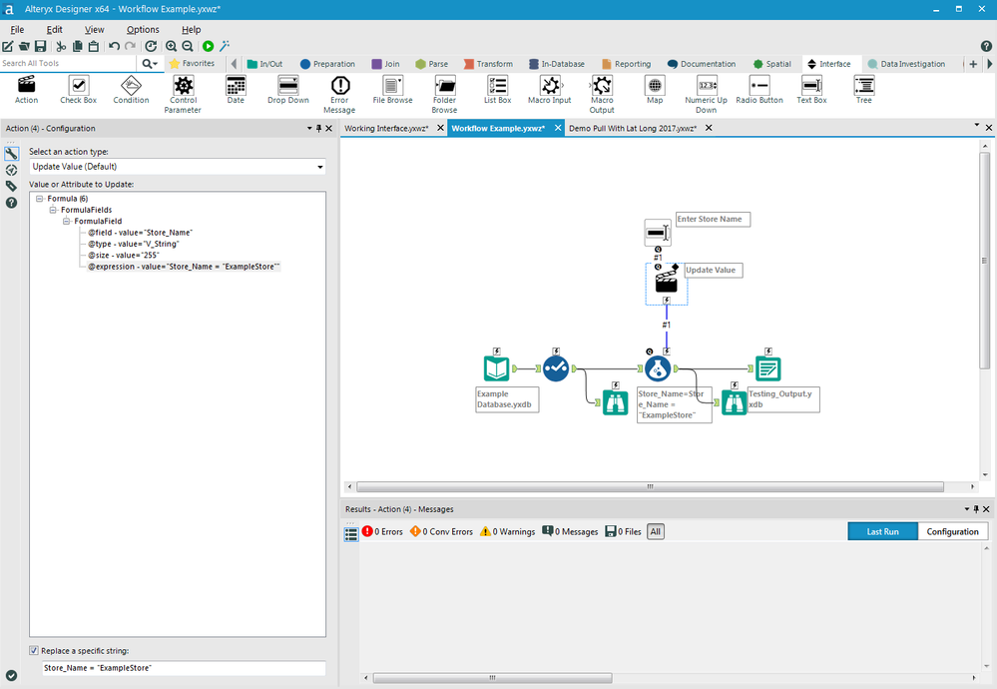
Fig 2.2 Screenshot of Altryx Platform

2.3 Leverton Platform Basics
Leverton is an AI-driven information extraction and management platform that leverages machine learning technology to automate the process of document management by creating structured data out of unstructured documents, enabling smarter and data-driven decisions for clients. This is one of the core client platforms used in the field of Real Estate Data Management.
Leverton provides teams with a ‘core’ of structured company data regardless of their size or scale, as all organisations work with legal documents. Its use cases range from large real estate due diligence processes and ongoing data and document management, to the facilitation of new accounting standards such as IFRS 16/ US GAAP ASC 842 and beyond.
From an accountant’s perspective, their activities can be divided into creative tasks i.e. analysis of data and uncreative tasks such as identification and classification of information from lease documents. The uncreative tasks usually take up much of their time, requiring a high degree of concentration and can often lead to potentially costly errors. Furthermore, as the process of data extraction is done manually, the scope for data analysis is often restricted, leading to sub-optimal and costly decision-making based on incomplete data.
This is where automation of data extraction comes as a real game-changer for accountants, who can now spend more time analysing extracted data and providing better services to clients instead of being bogged down by mundane paperwork.
Leverton’s deep learning platform is ideal for simplifying the transition to the new lease accounting standards through automated data extraction. The artificially intelligent technology gathers all leasing documents into a single platform, automatically categorises them and extracts all relevant information from leases. Once in a structured format, the extracted lease information can be imported into the companies’ preferred target systems such as lease management systems, saving both time and costs.

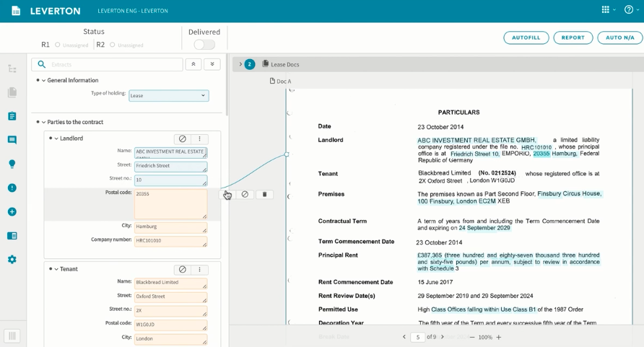
Fig 2.3 Screenshot of Leverton Platform

2.4 Cloud Basics
Data warehouse and Data lake are two terms that one comes across a lot whilst dealing with a large amount of data. Data Warehousing is the process of collecting and managing data from various services/sources. It’s a system used for reporting and data analysis processes and is considered as one of the core components of Business Intelligence. It is typically used to collect and analyse business data from heterogenous sources. It is a blend of technologies and components which aids the strategic use of data. It is electronic storage of a large amount of information by a business which is designed for query and analysis instead of transaction processing. It is a process of transforming data into information and making it available to users in a timely manner to make a difference.

A Data Warehouse works as a central repository where information arrives from one or more data sources. Data flows into a data warehouse from the transactional system and other relational databases.
Data may be:

- Structured
- Semi-structured
- Unstructured data

The data is processed, transformed, and ingested so that users can access the processed data in the Data Warehouse through Business Intelligence tools, SQL clients and flat files (incuding txt, excel and csv files). The data warehouse is used in such a way that it merges information coming from different sources into databases as needed by the business teams at JLL.

I have leveraged informatica cloud tools for this project.
Informatica Cloud is a data integration solution and platform that works like Software as a Service (SaaS). It integrates cloud-based data with the data residing in on-premise databases and systems or between cloud applications.

Informatica Cloud Data Integration is the cloud based Power Center which delivers accessible, trusted, and secure data to facilitate more valuable business decisions.
If we are using a cloud data warehouse like AWS Redshift, Azure SQL Data Warehouse, or Snowflake, we can use Informatica Cloud Data Integration solutions to help improve the overall performance, productivity, and extensive connectivity to cloud and on-premises sources.
Informatica Cloud can connect to on-premises and cloud-based applications (like Salesforce, Marketo, NetSuite, Workday) databases, flat files, file feeds, and social networking sites.

2.5 JSON Basics
JSON is a simple, text-based way to store and transmit structured data. It is one of the most
important flat files which is used to store structured data. By using a simple syntax, you can
easily store anything from a single number through to strings, arrays, and objects, using nothing
but a string of plain text. You can also nest arrays and objects, allowing you to create complex
data structures.
Once we have created the JSON string, it’s easy to send it to another application or computer,
because it’s just plain text.
JSON stands for JavaScript Object Notation. As the name implies, it’s based on the way you define objects and arrays.
2.5.1. A simple JSON example
The following example shows how we might store a simple shopping cart in JSON format:
{
"orderID": 12345,
"shopperName": "John Smith",
"shopperEmail": "johnsmith@example.com",
"contents": [
{
"productID": 34,
"productName": "SuperWidget",
"quantity": 1
},
{
"productID": 56,
"productName": "WonderWidget",
"quantity": 3
}
],
"orderCompleted": true
}

CHAPTER 3 METHODOLOGY

  - Introduction
This chapter first clearly defines the problem statement. Once a concrete understanding is established regarding the requirements and reason for doing this project are explained. After this Methodology is explained for the report in detail. Each phase in the process is clearly explained along with the reasons for using the approach.

Problem Statement
As mentioned before, Agenda for the project is to take the Altryx data, make a robust and diligent pipeline solution through ETL process, so that it is ‘ready data’, which can be further distributed to various downstream application.

Tools/Packages Used
Several tools and software have been used for extracting required data, automating the tagging process and designing the Dashboard:
- Altryx Platfrom for extracting Data
- Leverton Platform for Extracting/ Transferring data
- Jupyter Notebooks: The coding for the ‘ETL’ process is done in Jupyter notebooks using Python Language.
- Command Prompt: To run the script on Python, several functions are required. Python, being an open source, has plenty of libraries that host functions which have been helpful in scripting of the code required to design an interactive Dashboard. Command Prompt is used to install the required libraries.
- JSON Files: The data extracted from Altryx Platform is stored in the form of JSON flat files, which are then imported into Juypter notebooks for conversion into Python Dataframes.
- Flat Files – All the Dataframes in Python undergo an ETL (Extract, transform, load) process and are converted into three kinds of flat files, viz CSV, excel and text file.

As mentioned before, to run the script on Python, several functions are required. Python, being an open source, has plenty of libraries that host functions which have been helpful.

- Pandas: Pandas is the most widely used tool for data wrangling. It contains high-level data structures and manipulation tools designed to make data analysis fast and easy. DataFrame and, Reading and Writing into CSV files are one of major functions used in the project.
- Numpy: NumPy, which stands for Numerical Python, is a library consisting of multidimensional array objects and a collection of routines for processing those arrays. Using NumPy, mathematical and logical operations on arrays can be performed. This tutorial explains the basics of NumPy such as its architecture and environment. It also discusses the various array functions, types of indexing, etc. An introduction to Matplotlib is also provided. All this is explained with the help of examples for better understanding.
- Pandas System: The sys module provides functions and variables used to manipulate different parts of the Python runtime environment.
- CSV - The so-called CSV (Comma Separated Values) format is the most common import and export format for spreadsheets and databases. The csv module implements classes to read and write tabular data in CSV format. It allows programmers to say, “write this data in the format preferred by Excel,” or “read data from this file which was generated by Excel,” without knowing the precise details of the CSV format used by Excel. Programmers can also describe the CSV formats understood by other applications or define their own special-purpose CSV formats.
- Import Operating System(os): This module provides a portable way of using operating system dependent functionality. If you just want to read or write a file see open(), if you want to manipulate paths, see the os.path module, and if you want to read all the lines in all the files on the command line see the fileinput module. For creating temporary files and directories see the tempfile module, and for high-level file and directory handling see the shutil module.
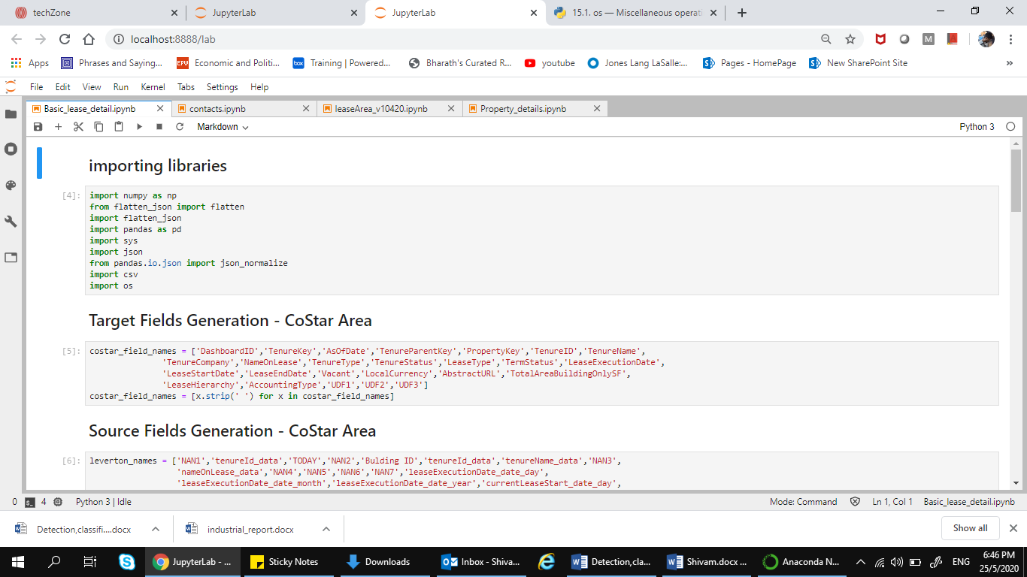
Fig 3.1 Screenshot of importing Python libraries

  - Assumption
- Leverton XML file will be always be similar with respect to its structure.
- Informatica Cloud process will be leveraged to convert JSON as it is.
- XQuery will be leveraged as is and will be executed by Informatica Cloud.
- Informatica Cloud process will be releasing JSON file after processing XML through XQuery.
- Stored Procedures will be leveraged and incorporated in below proposed plan to introduce business logics.

  - Approach
My approach is as follows:
- Convert the JSON file provided by Leverton into a flat file/ CSV file.
- Load data from flat/CSV file to STG table (One to One mapping).
- Process STG Table data by respective Stored Procedure (Built already and being use by Portfolio).
- Load processed data into final target tables.
- Create a delta cut from this data as per CoStart requirement.
- Transmission of delta file to CoStar end point.

  - Methodology
Step 1:
Leverton XML to JSON Files – This process is already existing and will be used in the similar way. The only adjustment is to make it reusable, and it will be driven by CoE.
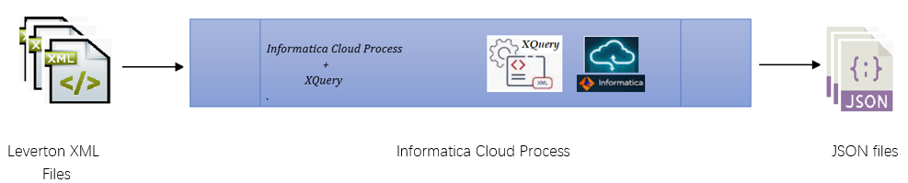
Fig 3.2 Overall structure of the journey

Step 2:
JSON files to Final Target Tables – This process is designed by CoE, where JSON files will be processed and loaded to final target tables, and it will be ready feed for down stream applications.
Stored Procedures have been built and are functional at Portfolio program which is required to integrate business logic on various STG tables. The same will be leveraged for our purpose.
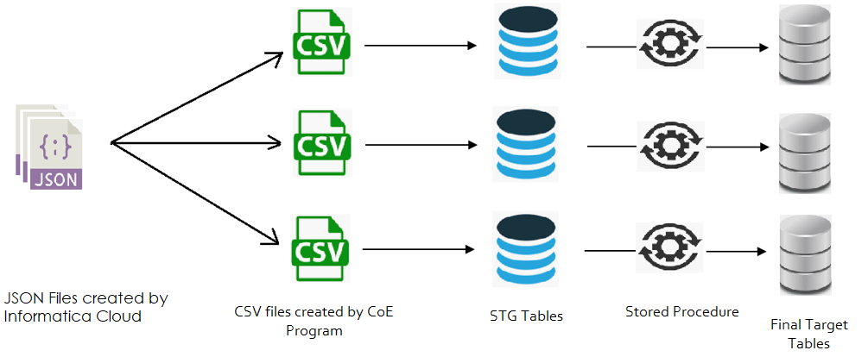
Fig 3.3 Extracting, transforming and loading the datasets into the data warehouse

This process includes below activities:
- JSON translation to flat/csv file (intermediate files) per node one file.
- One to One write for flat/csv file to its respective STG tables. (Required number of tables, tables names and respective metadata for tables – TBD. Based on information gathered from Portfolio team).
- Stored Procedures are processed to integrate business logic on STG tables.
- Writing ready feed data to respective final tables. (Required number of tables, tables names and respective metadata for tables – TBD).

Step 3:
Final Target Table to Ready feed files - This process is to extract delta cut from final target tables which hold ready feed for downstream applications.

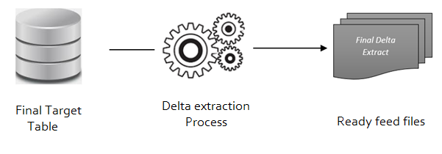
Fig 3.4 From final table to ready feed table

Step 4 – In the last process by CoE, ready feed files will be transmitted to downstream applications as required by the need.
The automation has been designed to run on Python language. But before we get to the automation part of the project, data needs to be extracted from AWS services and analysed

CHAPTER 4 RESULT ANALYSIS

  - Introduction
This chapter gives an insight on the data transferred from the altryx platform to the Leverton Platform. It also briefly touches the data alignment from different sources into one source. It also explains the significance of these results.

  - Result
This feature has not been yet deployed and is under development.
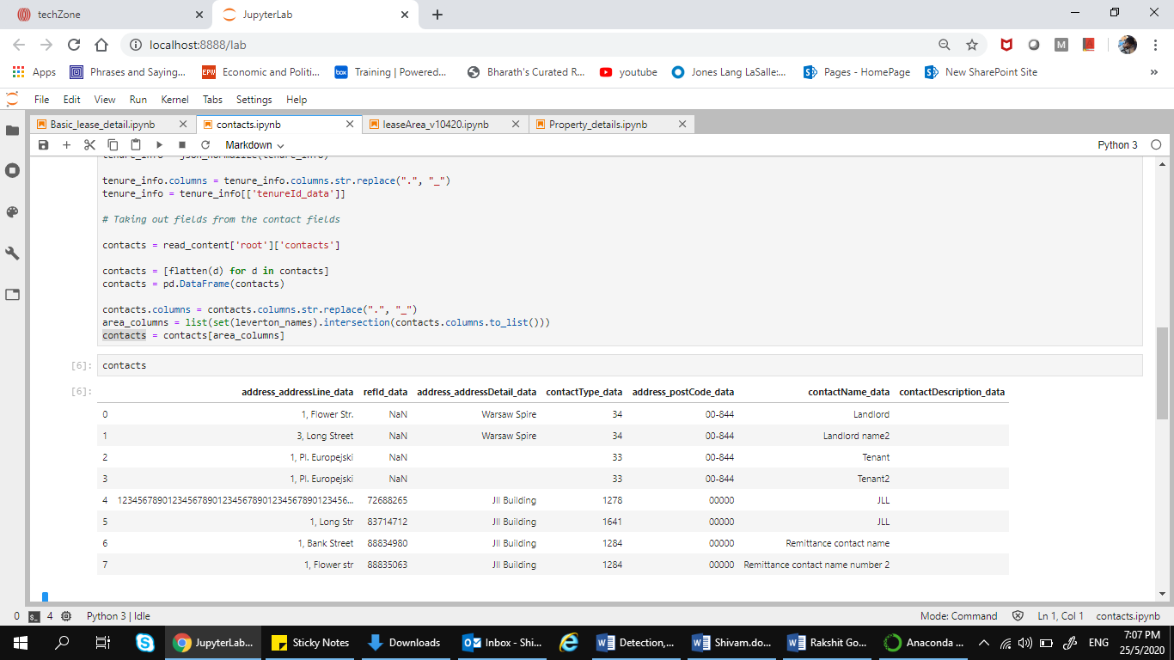

Fig 4.1 Importing datasets from Altryx Platform into Python environment

The dataset has been imported into the python environment and from here, the manipulation of datset starts. The manipulation is done according to the requirement of the business to get the best desired output from the data.
The data is then further exported into such a form so that it can be readily loaded into the Leverton Platform. The Leverton platform needs the data to be in CSV file with the delimiter ‘|’. For this, we convert the final data into a csv file and use the required delimiter as needed. The complete code journey was not allowed to be put into the report due to company policy and security concerns.

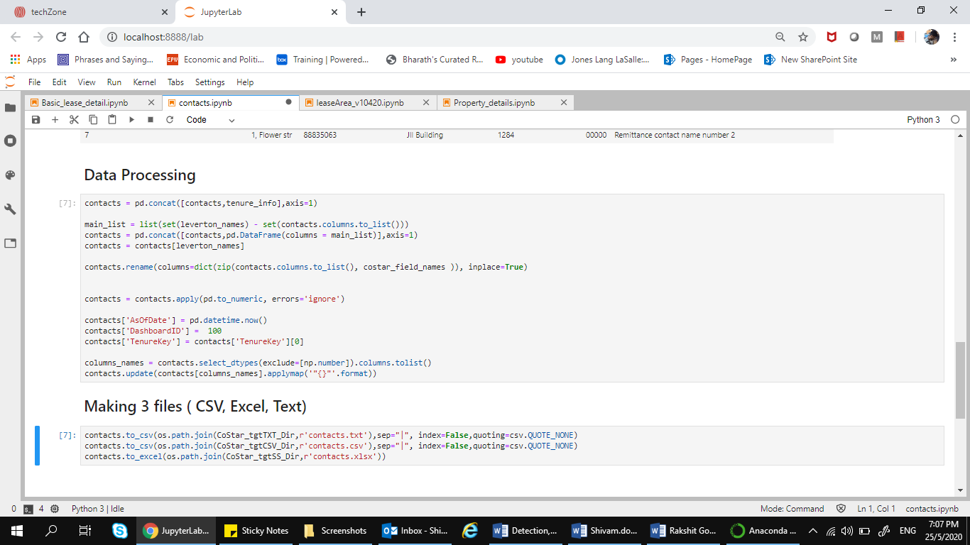
Fig 4.2 importing datasets from Altryx Platform into Python environment

  - Conclusion
This chapter talked about the various results which are aimed to be achieved during the course of the project. These results prove that there is lot more work that needs to be done in the field to make the ETL process good enough to be deployed on the JLL Technology servers.

CHAPTER 5
CONCLUSION AND FUTURE SCOPE OF WORK

  - Conclusion and Summary of Work
The objective of this project is to come up with a faster and efficient way of dealing with the cost aspect of AWS. This includes improving the current cost visibility and granularity offered by AWS Cost and Management tools. With the above approach the time taken to charge back the organisation can be cut down to almost half.
The work done till now, is identifying the gaps in the current cost management tools offered by AWS and coming up with a plan of action for the obstacles that we come across. The extraction of data from EC2 for designing the dummy dashboard. Getting familiar with the workings of the Dash library offered by Python to create the Dashboard. Creating the dashboard to meet the requirements as stated in the above chapters. As mentioned before there still a lot that can be achieved in this project in the upcoming months of the Internship.

Future Scope of Work
The future scope of work in this project consists mainly of designing a working and interactive Dashboard only consisting data related to Cost Explorer. Right now, the dashboard is designed keeping in mind EC2 service of AWS but moving forward changes will be made to customise it according to Cost Explorer and CloudWatch.
It will include data extracted from the CloudWatch metrics and logs which will then be combined with the parameters identified from the Cost estimate calculator to design an algorithm to calculate the cost of each resource on the go. The algorithm can be achieved by reverse engineering the current usage and cost.
Furthermore, automating the process of tagging is not enough. There are already hundreds of resources in play and tagging all of them in one go will take a lot of time. The automation process needs to be done in such a way that as soon as a resource is formed it is tagged rather than waiting for the user to run the program.

REFERENCES
[1] “Azure Databricks - A Complete Guide - 2019 Edition”, by Gerardus Blokdyk
[2]. Shayon Sanyal “Analyze your Amazon S3 spend using AWS Glue and Amazon, Redshift”, AWS Documentation, 24 Jan 2020
[3]. https://docs.aws.amazon.com/awsaccountbilling/latest/aboutv2/cost-alloc-tags.html
[4]. https://spark.apache.org/docs
[6]. Interactive Python Dashboards with Plotly and Dash, https://www.udemy.com/course/interactive-python-dashboards-with-plotly-and-dash/
[7]. https://docs.microsoft.com/en-us/azure/
[8]. Bar Charts in Python, https://plotly.com/python/bar-charts/ [10]. JMESPath Tutorial, https://jmespath.org/tutorial.html

PROJECT DETAILS

Student Details
Student Name | Shivam Pathak
Register Number | 160907344 | Section / Roll No | A 36
Email Address | shivam.mit20@gmail.com | Phone No (M) | 8602730879
Project Details
Project Title | ETL Pipeline Design for Call Centre Customer Service
Project Duration | 6 months | Date of reporting | 07-01-2020
Expected date of completion of project | 3-07-2020
Organization Details
Organization Name | JLL Technologies
Full postal address  with pin code | Prestige Trade Towers, Centre of Excellence(COE), JLL Technologies, Vasant Nagar, Bengaluru,  Karnataka 560052
Website address | https://www.jll.co.in/
Supervisor Details
Supervisor Name | Mr Joseph Vinod Miranda
Designation | Senior Director, Data Management
Full contact address  with pin code | Prestige Trade Towers, Centre of Excellence(COE), JLL Technologies, Vasant Nagar, Bengaluru,  Karnataka 560052
Email address | ganeshan1.rajan@ge.com
Internal Guide Details
Faculty Name | Dr. Somashekara Bhat
Full contact address  with pin code | Dept. of E&C Engg., Manipal Institute of Technology, Manipal – 576  104 (Karnataka State), INDIA
Email address | soma.bhat@manipal.edu

